

Financial Decision Making

Table of Contents

Introduction 2

Section-One 3

Discussion of the risk and return characteristics of different types of long-term sources of

finance in perspective Glaxo SmithKline UK 3

Critical evaluation of the pecking order theory and static trade-off theories 4

The sources of finance used by the GSK (UK) 5

Calculation and evaluation of the gearing ratio of the GSK (UK) 5

Section-Two 6

Critical evaluation of the different working capital theories 6

Calculation and evaluation of the different types of ratios of GSK (UK) 8

Section-Three 10

Critical evaluation of the different types of financial theories 10

Application of the different theories in GSK (UK) 10

Section-Four 11

Calculation and evaluation of the profitable ratio 11

Evaluation of the return in relation to risk 12

Analysis of the external economic environment for the GSK (UK) 13

Evaluation and application of the Minsky analysis 14

Conclusion 14

References 15

Page 1 of 15
Introduction

As finance is considered as the blood flow of the business, the finance manager of the business has to consider the risk, return, economic condition, and profitability when making the financial decision. This assignment has been prepared by emphasizing financial decision making in the context of Glaxo SmithKline (GSK), UK. The different sources of finance have been analysed firstly in this assignment along with their risk, return, and availability. The relationship between risk and return has been also discussed in this assignment using SML and CAPM.

Page 2 of 15
Section-One

Discussion of the risk and return characteristics of different types of long-term sources of finance in perspective Glaxo SmithKline UK

The owners and promoters of the business organisation have invested to make a profit as a return (Cinnamon, Helweg-Larsen and Cinnamon, 2016). The long-term sources of finance for the Glaxo SmithKline UK have been identified below along with their risk and return characteristics:

Internal equity: The internal equity has been formed with an accumulation of the profit from the business operation (EISEN, 2019). The finance manager of the Glaxo SmithKline UK has not to issue shares in the market to form the internal equity. The finance manager of the GSK (UK) has reduced its issuing and underwriting cost for issuing new share capital when the finance manager has taken the initiative to use retained earnings for making further long-term investments. The existing shareholders of the GSK (UK) have got benefit by controlling their position in the business by using the retained earnings as long-term sources of finance (Helbæk, Lindset and McLellan, 2016). There has a risk to decrease the market price of the shares of the GSK (UK) because shareholders may be dissatisfied when the dividend has not declared by the GSK (UK).

Bank loan: The company has taken loan for covering of the short-term requirements of the funds and long-term requirements of the funds (Home | GSK UK, 2020). Sometimes, the business organisation like GSK (UK) has faced challenged for the working capital because of increasing of the accounts receivable, inventories, and raw materials. In this case, the GSK (UK) has taken short-term loan as bank overdraft from the commercial bank. The cost of the bank over the draft loan is very flexible because interest has been charged when the loan has been drawn from the bank (Horngren and Harrison, 2015). The GSK (UK) has to pay a significant amount to the bank as interest and arrangements fee when GSK (UK) has taken bank overdraft loan facilities. There has a risk to face financial distress as paying excess interest to the bank for using overdraft loan facilities (Jones, 2013). The finance manager of the GSK (UK) has not required to take any initiatives for performing due diligence audit to take long-term loan facilities. The GSK (UK) has to pay a significant amount to the bank as interest and arrangements fee when GSK (UK) has taken long-term loan facilities (Kimmel, 2018).

Page 3 of 15

Market debt: The management of the GSK (UK) can decide to issue debenture and bonds to the public to collect money for the long-term (Koch and MacDonald, 2016). As a financially sound company, the GSK (UK) has issued the secured bond to the public. The GSK (UK) has to pay a reasonable amount as interest for the secured bond. The financially unsound business organisation has issued the unsecured loan without providing any acknowledgements of indebtedness. The business organisation which has issued unsecured bond has to pay a large amount of money as interest because the buyers of the unsecured loan have taken the high risk (Lough, 2013).

Convertible loan and shares: The management of the GSK (UK) can take the opportunity of paying lower interest for convertible bond due to option to convert (Pandey, 2015). The GSK (UK) has formed by issuing common stock to the public to introduce itself as a public limited company. The management of the GSK (UK) has to pay underwriting expense, listing fee, prospectus publication fee, and other regulatory fees to issue common stock. The GSK (UK) can get the tax benefit for the partial time by issuing a convertible bond. As investors of the ordinary shareholders have taken a high risk, the GSK (UK) has to pay a higher amount of return to the investors (Paramedian and Subramanian, 2019).

Critical evaluation of the pecking order theory and static trade-off theories

The pecking order theory of finance has preferred retained earnings firstly, debt finance secondly, and equity finance lastly (Pratt, 2017). This theory has discouraged to issue new shares because issuing of new share has reduced the confidence of the existing investors and the market value of the stock has been decreased. On the other hand, the using of the debt capital and retained earnings indicate that the existing market value of the equity is undervalued and existing stockholders feel confident about their investments as a result market price of the share has been increased. The business organisation has not followed the pecking order theory all time because using more debt leads to the probability of facing severe financial distress (Rose and Hudgins, 2014). The trade-off theory of finance has said that there has no effect of capital structure on values of the firm when there has no tax in the economy. Furthermore, the tradeoff theory of finance has said that the value of the firm will be increased when the firm has used a mixture of debt and equity in capital structure along with corporate tax bracket. As per trade-off theory, the value of the firm will be increased when fir can use debt with a lower cost than the cost of equity and higher corporate tax bracket (Sharma, 2016).

Page 4 of 15

The sources of finance used by the GSK (UK)

The sources that are used by the GSK (UK) for financing activities are mentioned and discussed below:
- Short-term borrowings

- Long-term borrowing

- Share capital

As the GSK (UK) has used both long-term borrowing and share capital in its capital structure, the GSK (UK) has followed the proposition 2 of trade-off theory. As per proposition 2 of the trade-off theory, the value of the GSK (UK) will be increased when the firm has used a mixture of debt and equity in capital structure along with higher corporate tax bracket.

Calculation and evaluation of the gearing ratio of the GSK (UK)

Gearing ratio has measured mixture of equity capital and debt capital in the capital structure. The gearing ratio of the GSK (UK) has calculated below based on financial statements for the year ended 2019:
Debt to equity ratio = |  | = | 23,590 |  |  | = 2.06
Debt to equity ratio = |  | = | 11,405

The above-calculated debt to equity ratio of the GSK (UK) has shown that the GSK (UK) has taken £2.06 as debt for £1 of equity. The GSK (UK) can derive financial benefits from its existing capital structure because this business organisation has belonged to large corporate tax bracket.

Page 5 of 15
Section-Two

Critical evaluation of the different working capital theories

The daily cash requirements for the business operation has been met by the working capital that can be derived by subtracting of the current liabilities from the current assets (EISEN, 2019). The business organisation like GSK (UK) follow the following theories and strategies for managing the working capital requirements:

Matching theory: This theory of managing of the working capital of the business organisation is known as the moderate approach under which the capital expenditure has been financed by the long-term sources of funds and current assets have been incurred by the short-term sources of finance.
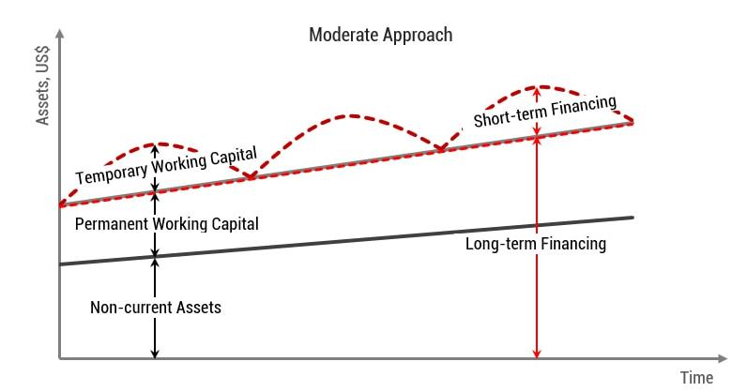

Figure 1: Moderate approach of working capital management
Source: (EISEN, 2019)

Page 6 of 15

Conservative theory: This theory of managing of the working capital of the business organisation is known as the low risk-low return approach under which the capital expenditure, the permanent working capital requirements have been financed by the long-term sources to reduce risk of the interest rate fluctuations (Helbæk, Lindset and McLellan, 2016).
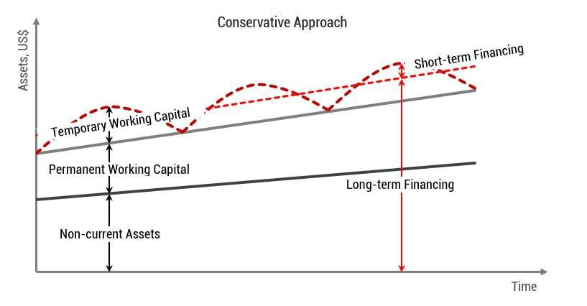

Figure 2: Conservative approach of working capital management
Source: (EISEN, 2019)

Page 7 of 15

Aggressive theory: This theory of managing of the working capital of the business organisation is known as the riskiest approach under which the temporary and permanent working capital requirements have been financed by the short-term sources to get more return (Horngren and Harrison, 2015).
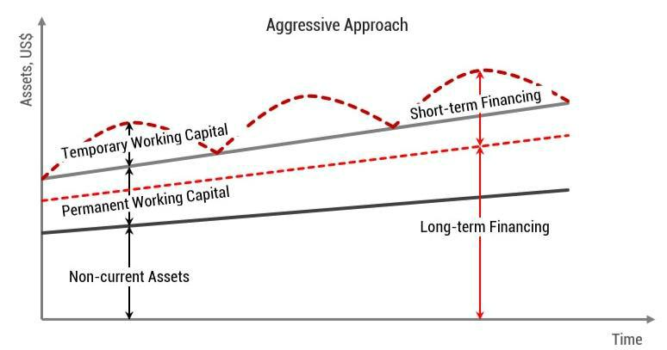

Figure 3: Aggressive approach of working capital management
Source: (EISEN, 2019)

Calculation and evaluation of the different types of ratios of GSK (UK)
Current ratio = |  | = | 19,491 |  |  | = 0.81:1
Current ratio = |  | = | 24,050

The result of the current ratio of GSK (UK) has identified that GSK (UK) has a £ 0.81 current asset against £1 of current liabilities for the year-end 2019. The GSK (UK) should improve its liquidity position to recover its liquidity crisis and to improve its ability to pay current liabilities (Home | GSK UK, 2020).
Liquidity ratio = | − − | = | 13,544 |  | = 0.56:1
Liquidity ratio = |  | = | 24,050 |  | = 0.56:1

The result of the liquidity ratio of GSK (UK) has identified that GSK (UK) has a £ 0.56 liquid asset against £1 of current liabilities for the year-end 2019. The GSK (UK) should improve its liquidity position to recover its liquidity crisis and to improve its ability to pay current liabilities instantly.

Page 8 of 15
Inventories outstanding days = |  | ×365= | 5,711 |  | × 365 = 175 days
Inventories outstanding days = |  | ×365= | 11,873 |  | × 365 = 175 days

The result of inventories outstanding days of GSK (UK) has identified that the GSK (UK) has taken averagely 175 days to covert its inventories into cash. The inventories outstanding days of GSK (UK) is high and GSK (UK) should reduce its inventories outstanding days to reduce its cash conversion cycle.
Receivable outstanding days = |  | ×365= | 7,202 |  | × 365 = 78 days
Receivable outstanding days = |  | ×365= | 33,754 |  | × 365 = 78 days

The result of receivable outstanding days of GSK (UK) has identified that the GSK (UK) has taken averagely 78 days to covert its receivable into cash. The receivable outstanding days of GSK (UK) is perfect and GSK (UK) should maintain its current receivable outstanding days to improve its cash conversion cycle.
Payable outstanding days = |  | ×365= | 14,939 |  | × 365 = 459 days
Payable outstanding days = |  | ×365= | 11,863 |  | × 365 = 459 days

The result of payable outstanding days of GSK (UK) has identified that the GSK (UK) has taken averagely 459 days to pay its payables by using cash. The payable outstanding days of GSK (UK) is perfect and GSK (UK) should maintain its current payable outstanding days to improve its cash conversion cycle.

Cash conversation cycle = Inventories outstanding days + Receivable outstanding days - Payable outstanding days

= 175 + 78 – 459 = (206) days

The result of the cash conversion cycle of the GSK (UK) is very positive to maintain liquidity and this above-calculated result indicates that the GSK (UK) has got credit benefits from its suppliers for significant times (Home | GSK UK, 2020).

Page 9 of 15
Section-Three

Critical evaluation of the different types of financial theories

Dividend irrelevance theory: As per Modigliani and Miller (MM), the pattern of paying a dividend to the shareholders is irrelevant in terms of maximizing shareholder’s wealth. The

- theory has stated that dividend policy is irrelevant as the source of equity finance is irrelevant (Horngren and Harrison, 2015). The MM theory has also stated that the amount of dividend paid is relevant although dividend policy is irrelevant.

Clientele effect: The investors who have preferred current income chose a higher amount of dividend. On the other hand, the investors who have been belonged to the large corporate tax have preferred the capital gain. As per the clientele effect, the investors have switched investment opportunities when the company has made major changes in dividend policy (Jones, 2013).

Birds in hand theory: The birds in the hand theory has focused on certainty and present return rather than a future opportunity (Koch and MacDonald, 2016). This theory has been followed by risk-averse people. This theory stated that receiving £1 currently as the dividend is more worth than receiving capital gain in future.

Signalling effect: The paying dividend to shareholders has a positive impact to increase the confidence of the shareholders as well as to the market value of the shares. The shareholders can assess future earnings and certainty based on paying ratio of the dividend. The signalling effect has supported the relevancy of the dividend policy (Kimmel, 2018).

Application of the different theories in GSK (UK)

The GSK (UK) has followed the consistent dividend policy to satisfy investors as well as to maximize the value of the company. From the financial statements of the GSK (UK), it has identified that the GSK (UK) has paid dividend £3,953, £3,927, and £3,906 respectively for the year-end 2019, 2018, and 2017 to its shareholders. In that case, it could be explained that the GSK (UK) has given emphasizes on signalling effects of dividends by assuming that dividend policy is relevant. On the other hand, the GSK (UK) has retained its residual profit after paying profits as dividends to maximize value by making further investments from the internal equity sources of finance (Pandey, 2015).

Page 10 of 15

Section-Four

Calculation and evaluation of the profitable ratio
Gross profit margin ratio = |  | ×100= | 21,891 |  | × 100 = 64.85%
Gross profit margin ratio = |  | ×100= | 33,754 |  | × 100 = 64.85%

The above calculated gross profit margin of the GSK (UK) is satisfactory compared to the industry average and the gross profit margin is 64.85%.
Net profit margin ratio = |  | ×100= | 5,268 |  | × 100 = 15.60%
Net profit margin ratio = |  | ×100= | 33,754 |  | × 100 = 15.60%

The above calculated net profit margin of the GSK (UK) is not satisfactory compared to the industry average and the net profit margin is 15.60%. The finance manager of the GSK (UK) has to take initiative to reduce its operating expenses and increases its net profit margin.
Return on asset = |  | ×100= | 5,268 |  | × 100 = 7.65%
Return on asset = |  | ×100= | 68,879 |  | × 100 = 7.65%

The GSK (UK) can generate £7.65 as net income by utilizing £100 of the asset. The finance manager of the GSK (UK) has to emphasize to improve its ability to generate more net income by using its asset.
Return on equity = |  | ×100= | 5,268 |  | × 100 = 47.83%
Return on equity = |  | ×100= | 11,014 |  | × 100 = 47.83%

The GSK (UK) can generate £47.83 as net income by utilizing £100 of equity. The finance manager of the GSK (UK) has to emphasize to maintain its ability to generate more net income by using its equity (Home | GSK UK, 2020).

Page 11 of 15

Evaluation of the return in relation to risk

The return of the investment has been dependent on the risk of the investments because there has a positive correlation between risk and return (Koch and MacDonald, 2016). The relation of the risk and return has been shown below by drawing SML and using CAPM:
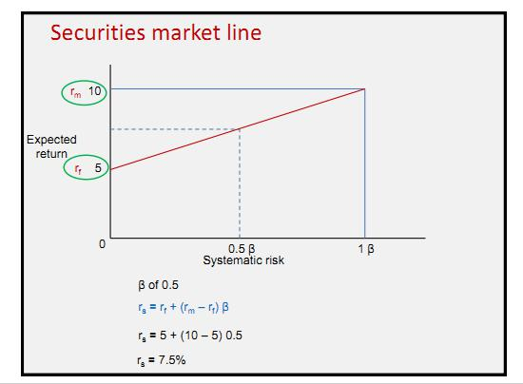

Figure 4: Security market line
Source: (Koch and MacDonald, 2016)
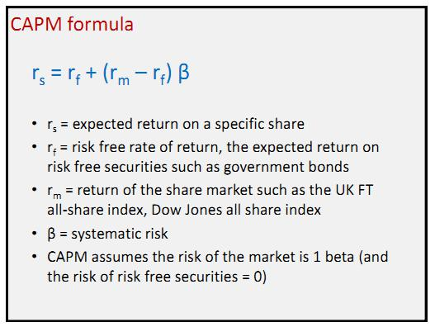

Figure 5: Capital Asset Pricing Model
Source: (Koch and MacDonald, 2016)

Page 12 of 15

From the above picture, we have seen that the return of the investors has increased when the intensity of the risk has been increased (Lough, 2013). The market risk of the investment has been expressed through using of the ß. The return for the investors has been also calculated by using the Capital Asset Pricing Model (CAPM). As per CAMP and SML, we have seen that the investor has got greater return when the value of the ß is 1 than the value of the ß is 0.50. So there has a positive relationship between the expected return on investment and risk of the investment.

Analysis of the external economic environment for the GSK (UK)

The operation of the business has been affected by both internal and external environment because the business has taken opportunities from each element of the environment. The external economic environment for GSK (UK) has been analysed using PEST model:

Political environment: The government of the UK has a very positive perception of pharmaceuticals and health care business organisation. The government of UK has provided tax holiday scheme, and incentives opportunities to expand pharmaceuticals and health care business in the UK.

Economic environment: The economic condition of the UK is not good at all because of the pandemic situation of COVID 19. The GDP growth rate of the UK has been decreased by 2.20% compared to the immediate previous year’s GDP.

Social environment: AS the people of the UK are more concerned about their health and lifestyle, the GSK (UK) can take the business opportunity by providing quality and trustworthy service to general people. Approximately 99% of people in the UK are literate and well educated about health care service.

Technological environment: The government of the UK has invested with £400 million to establish a new hi-tech business organisation. Furthermore, the GSK (UK) has got all technological facilities to run its business from the government of the UK and other stakeholders.

Page 13 of 15

Evaluation and application of the Minsky analysis

Minsky moment has occurred when investors have taken a large amount of loan and debt from the financial intuitions and made investments in the capital market during the bullish period (Pandey, 2015). The capital market and financial market have faced the Minsky moment when investors have taken an excessive amount of the credit to get more return. Furthermore, there can lose the investment of rational investors because of the Minsky effect. When the market has come back to the normal market trend from the Minsky moment, the value of the equity has started to reduce and the investors have lost their investments. On the other hand, the liquidity crisis has been seen in the economy after the occurrence of the Minsky effect (Paramasivan and Subramanian, 2019).

Conclusion

The GSK (UK) will get financial benefits from its investments when the finance manager of the GSK (UK) can identify the profitable and appropriate sources of finance. In the time of selection of the appropriate source for finance, the finance manager of the GSK (UK) has to consider the related cost, risk, and availability of the funds. The calculated gross profit margin of the GSK (UK) is satisfactory compared to the industry average and the gross profit margin is 64.85%.

Page 14 of 15
References

Cinnamon, R., Helweg-Larsen, B. and Cinnamon, P., 2016. How To Understand Business Finance. London: Kogan Page.

EISEN, P., 2019. ACCOUNTING. [S.l.]: BARRONS TEST PREP.

Helbæk, M., Lindset, S. and McLellan, B., 2016. Corporate Finance. Maidenhead, Berkshire:
Open University Press/McGraw-Hill Education.

Horngren, C. and Harrison, W., 2015. Accounting BSB110 (Custom Edition). Melbourne: P.
Ed Custom Books.

Jones, M., 2013. Accounting. Hoboken: John Wiley Inc.

Kimmel, P., 2018. Accounting. New York: Wiley.

Koch, T. and MacDonald, S., 2016. Bank Management. Australia: South-Western CENGAGE Learning.

Lough, W., 2013. Business Finance. [Place of publication not identified]: Theclassics Us.

Pandey, I., 2015. Financial Management. New Delhi: Vikas Publishing House PVT LTD.

Paramasivan, C. and Subramanian, T., 2019. Financial Management. New Delhi: New Age International (P) Ltd., Publishers.

Pratt, J., 2017. Financial Accounting In An Economic Context. New York: Wiley.

Rose, P. and Hudgins, S., 2014. Commercial Bank Management. New York: McGraw-Hill/Irwin.

Sharma, N., 2016. Business Finance. New Delhi: Global Media Publications.

Uk.gsk.com. 2020. Home | GSK UK. [online] Available at: <https://uk.gsk.com/en-gb/> [Accessed 22 July 2020].

Page 15 of 15

